




Naufar

Time Integration Document

Integration of Time Recording Terminals with SAP HANA

TABLE OF CONTENT

1. Overview 4
2. Scope 5
2.1. Outbound Interface: 5
2.2. Inbound Interface: 5
3. Key data objects of Integration 6
4. Objective of Integration 6
5. SAP and Time recording Terminal (TIMENEX) field Mapping 7
5.1. Personal Information: Outbound 7
5.2. Roster Outbound: 7
5.3. Absence: Outbound 8
5.4. Public Holidays: Outbound 8
5.5. Clock in/Clock out Inbound 9
5.6. Roster Inbound 11
6. Integration Steps and Role of Each Party 12
7. Error Handling Scenarios: 18
8. Ponits to be noted 18

Overview

KAAR and Third Party Time Recording Terminals (TIMENEX) will work together to integrate SAP, Third Party Time Recording Terminals (TIMENEX) being used by Naufar. We are going to communicate with Time recording terminal using webservices through Process Orchestration (PO 7.5) as a middleware in other words SAP PI/PO (SAP middleware) will be used to send the data to webservice provided by Third Party Time Recording Terminals (TIMENEX).Also SAP Will receive the data through web services from Time recording terminals in the specified format which will be converted as a text file and uploaded using standard programs.
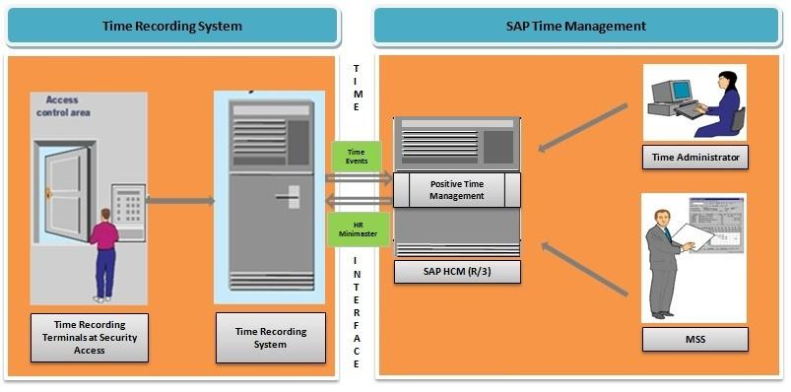

Scope
Integration scope is Bi-directional data flow from SAP to Third party time recording Systems (TIMENEX) through SAP PI/PO system.

Outbound Interface:
- The time recording terminals will provide the web services to SAP upon which custom ABAP program will download the data and push to time recording Terminals through Interface program using PI.
- After pushing the data to Time recording terminals the data will be saved in the archived folder in the Excel or Text Format. The archiving will be maintained for last 15 days of data to address any discrepancies in the data with TIMENEX system.
- The first run will contain the full employee’s master data. Subsequent runs will be only for incremental data – (change, including additional new hiring.)
- There may be a need to run the program for full load later on. Hence, we will provide a checkbox for Full Load. If the checkbox for Full Load is checked, the download program will extract full data for active employees on that day. Otherwise, it will just extract incremental data
A background job program will be scheduled to run the download program once every night to extract the HR mini-master data from SAP. The data from SAP will be picked up by outbound interface program (SAP PI) and sent to time recording system’s.
The detailed mapping is mentioned in the below document.

Inbound Interface:
- The time recording terminals will transmit the data through a webservice, which will be converted by SAP PO/PI as a text file and feed to the standard program as in put to upload the data in to SAP.
- SAP provides a standard upload program RPTEUP10 to upload time events into the interface table “CC1TEV”, which may required to be enhanced based on the data required in SAP.
- A background job will be scheduled and triggered once the data is transferred through the webservices by time recording terminals and gets upload to an interface table CC1TEV.
- HR Time Events Posting Program: After the file contents are uploaded into interface table CC1TEV, the next step is to post the time events from the interface table CC1TEV into TEVEN table. SAP provides a standard program SAPCDT45 to post time events from interface table CC1TEV into TEVEN table, which is required to modify to take only one in and one out in a particular day.
- A background job program will be scheduled to run this custom posting program once in a day to get the previous day records from CC1TEV interface table to TEVEN table

Key data objects of Integration
- Personal Information - Outbound from SAP
- Roster definition - Master Data - Outbound from SAP
- Absence record – Outbound from SAP
- Public Holidays – Outbound from SAP
- Clock in/Clock out – Inbound to SAP from Time Attendance system
- Actual Roster - Inbound to SAP from Time Attendance System

Objective of Integration
Below the integration objective
- Objective is to record the clock in and clock out of each employee for each data from third party time recording terminals(TIMENEX)
- Roster updation Periodically

SAP and Time recording Terminal (TIMENEX) field Mapping

Personal Information: Outbound
Position | Field Name | Data Type | Table | Length | Short Description | Remarks for SAP Team
1 | PERNR | NUMC | Pa0001 | 8 | Personnel/Employee Number
2 | NAME | CHAR | pa0002 | 40 | Name of the Employee
3 | ORGEH | NUMC | Pa0001 | 8 | Organizational Unit
4 | PLANS | NUMC | T528T-PLSTX | 8 | Position
5 | DRS | NUMC |  | 8 | Supervisor’s Personnel Number | Same logic as Leave
6 | WERKS | CHAR | Pa0001 | 4 | Personal Area code
7 | NAME1 | CHAR | T500P-NAME1 | 30 | Personal Area text(Clinical or Non- Clinical)
8 | STAT2 | CHAR | pa0000 | 10 | Employment Status (Active or Separated)
9 | USRID_LONG | CHAR | pa0105 | 241 | Email Address

Roster Outbound:
Position | Field Name | Data Type | Table | Length | Short Description | Remarks for SAP Team
1 | Roster_Code | CHAR | ZNAUF_PARAMETRS | 8 | Roster Code (e.g. SH-A) | Refer logic 1 below
2 | Roster_Name | CHAR | ZNAUF_PARAMETRS | 100 | Roster Name (e.g. Shift A) | Refer logic 2 below
2 | SOBEG | TIMS | V_T550A | 8 | Shift Start Time (e.g. 06:00) | Refer logic 3 below
3 | NOEND | TIMS | V_T550A | 8 | Shift End Time (e.g. 14:00) | Refer logic 3 below

Logic 1: Pass the Code name “NFRROS” in the parameters table mentioned in above table and take the value
Logic 2: Pass the Code name “NFRROS” in the parameters table mentioned in above table and take the value and description
Logic 3: Pass the Code name “NFRROS” in the parameters table mentioned in above table and take the process name against each value and pass in V_t550A and take start and end time

Absence: Outbound

Position | Field Name | Data Type | Table | Length | Short Description | Remarks for SAP Team
1 | PERNR | NUMC | PA0000 | 8 | Personnel number | Refer Logic 1
2 | AWART | CHAR | PA2001 | 4 | Leave Type
3 | BEGDA | DATS | PA2001 | 8 | Leave Start Date
4 | ENDDA | DATS | PA2001 | 8 | Leave End Date

Logic 1: Pass the employee number in PA0000 and check for the employment status i.e; STAT2=3.

Public Holidays: Outbound

Position | Field Name | Data Type | Table | Length | Short Description | Remarks
1 | Holiday | CHAR | THOC | 30 | Holiday Name
2 | DATE | DATS | THOC | 8 | Date
3 | Holiday Calendar | CHAR | THOC | 2 | Holiday Calendar ID

Clock in/Clock out Inbound

Position | Field Name | Data Type | Length | Short Description | Remarks for Vendor
1 | SATZA | CHAR | 3 | Time Event Type | "P10” – for Punch In or “P20” for Punch Out
2 | LDATE | DATS | 8 | Login/Logout Date(YYYYMMDD) | “YYYYMMDD” Format
3 | LTIME | CHAR | 6 | Login/Logout Time(HHMMSS) | “HHMMSS” Format
4 | PERNR | NUMC | 8 | Personal Number
5 | DALLF | CHAR | 1 | “X” for Previous Day blank for current date | if the roster is continued to next day, TIMENEX Needs to provide the Punch Out date for the previous day instead of actual date of Punch Out, with indictor of X

Consideration for SAP Technical Team only

SAP team needs to convert the data as per the format below:
Example: Employee 100203 has clocked in at 7.30AM on 31st Dec 2019 requires in a format as “p10201901317300000100203”

Below tables are meant only for SAP technical Team for their clarification for the format

Field | Format | Remarks
Time Event Type | P10 or P20 | Provide P10 for Clock in&P20 for Clock Out
Login Date (YYYYMMDD) | 20190131
Login Time (HHMMSS) | 73000
Personnel Number | 00100203 | 00100203

SAP has to convert in the below format before uploading.
Field | Format | Remarks
Time Event Type | Clock in-P10,Clock out -P20 | Provide P10 for Clock in&P20 for Clock Out
Terminal ID | 100203 | Perner id
Login Date (YYYYMMDD) | 20190131
Login Time (HHMMSS) | 73000
Date of Entry in SAP (YYYYMMDD) | 8Spaces | Convert as System Date
Time of Entry in SAP (HHMMSS) | 6Spaces | Convert as system Time
Time Recording ID | 8Spaces | 8 Digit Perner
Personnel Number | 00100203 | 00100203

Roster Inbound

Position | Field Name | Data Type | Length | Short Description | Remarks
1 | Roster_Code | CHAR | 8 | Roster Description
2 | PERNR | NUMC | 8 | Personal Number
3 | From Date | DATS | 8 | Roster Start Date
4 | To Date | DATS | 8 | Roster End Date

Sap has to convert the above Roster data in the below format and upload in the PA2003 table
The Roster value will be passed in the parameter table along with the code NFRROS and take the process name and create a Roster record in the table PA2003 with the start and end date given by TIMENEX.

Integration Steps and Role of Each Party

Step 1: SOAP is an acronym for Simple Object Access Protocol. It is an XML based messaging protocol for exchanging information between different systems.

Using SOAP Protocol, all HR Personal information will be sent to SAP Process Orchestration (PI/PO) system which is a middleware to transfer data from SAP S/4 HANA system to Time Recording System.

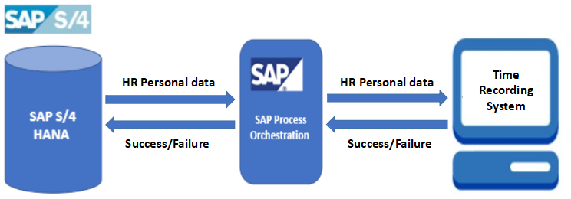

Role of Kaar: Background program to be scheduled in SAP system which initiates the HR Personal data transfer to Time Recording system on a daily basis. SAP will post the data to the webservice Personal data update action of webservice shared by Time Recording system.
The first run will contain data for all employees. Subsequent runs will be only incremental data – changed or additional data for employees

Role of Time Recording System: Time Recording System needs to share their webservice URL in which SAP will post the HR Personal data. Once data processed successfully, Time Recording system responds with Success / Failure message.
Frequency of Data flow: Once in a day 11: 55 pm.
Step 2: Roster data will be sent to SAP Process Orchestration (PI/PO) system which is a middleware to transfer data from SAP S/4 HANA system to Time Recording System.

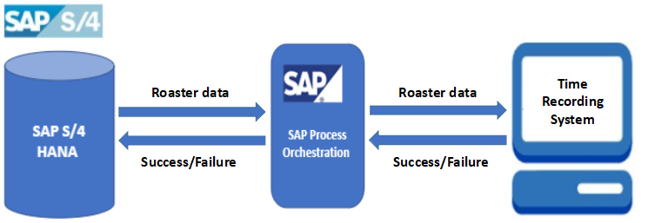

Role of Kaar: Background program to be scheduled in SAP system which initiates the Roster data transfer to Time Recording system. SAP will post the data to the webservice Roster data update action of webservice shared by Time Recording system.

Role of Time Recording System: Time Recording System needs to share their webservice URL in which SAP will post the Roster data. Once data processed successfully, Time Recording system responds with Success / Failure message.

Frequency of Data flow: Once in a day 11: 55 pm.

Step 3: Absence data will be sent to SAP Process Orchestration (PI/PO) system which is a middleware to transfer data from SAP S/4 HANA system to Time Recording System.

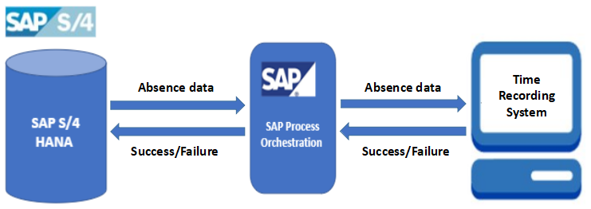

Role of Kaar: Background program to be scheduled in SAP system which initiates the Absence data transfer to Time Recording system. SAP will post the data to the webservice Absence data update action of webservice shared by Time Recording system.

Role of Time Recording System: Time Recording System needs to share their webservice URL in which SAP will post the Absence data. Once data processed successfully, Time Recording system responds with Success / Failure message.

Frequency of Data flow: Event based, once the leave record gets approved in SAP.

Step 4: Public Holidays information will be sent to SAP Process Orchestration (PI/PO) system which is a middleware to transfer data from SAP S/4 HANA system to Time Recording System.

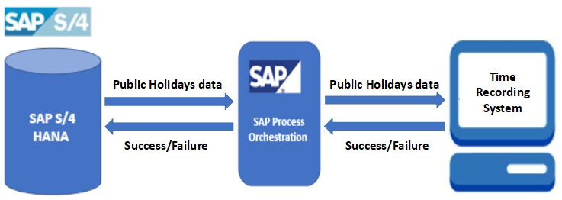

Role of Kaar: Background program to be scheduled in SAP system which initiates the Public Holidays data transfer to Time Recording system. SAP will post the data to the webservice Public Holidays data update action of webservice shared by Time Recording system.

Role of Time Recording System: Time Recording System needs to share their webservice URL in which SAP will post Public Holidays data. Once data processed successfully, Time Recording system responds with Success / Failure message.

Frequency of Data flow: Once in a day 11: 55 pm.

Step 5: Time Recording System will send the Clock in/Clock out data at regular intervals to the SAP system through SAP Process Orchestration system (SAP PI/PO).

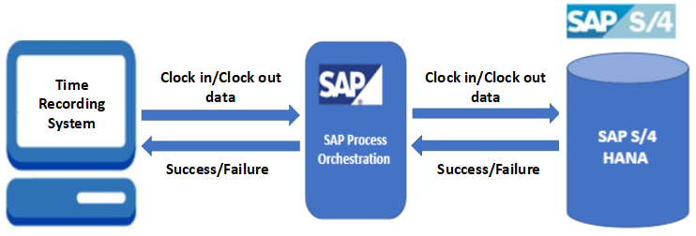

Role of Kaar: SAP needs to share the webservice URL to Time Recording System to post the Clock in/Clock out data to the webservice and consume the data that is sent by Time Recording System.

Role of Time Recording System: Time Recording System use the webservice shared by SAP to post the Clock in/Clock out data to the Time Events update action of webservice.

Frequency of Data flow: Every 10 minutes, the data needs to be pushed.

Step 6: Time Recording System will send the Roster data at regular intervals to the SAP system through SAP Process Orchestration system (SAP PI/PO).

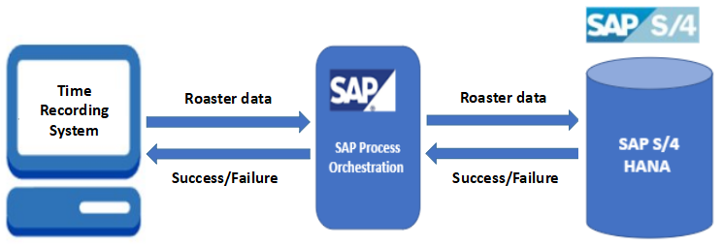

Role of Kaar: SAP needs to share the webservice URL to Time Recording System to post the Roster data to the webservice and consume the data that is sent by Time Recording System.

Role of Time Recording System: Time Recording System use the webservice shared by SAP to post the Roster data to the Time Events update action of webservice.

Frequency of Data flow: Once in a day 11: 55 pm.

Error Handling Scenarios:
In case of failure in integrating data, HR Personal information, Roster, Public Holidays and Absence data backup is carried in SAP log table and Time Integration System will send the failure response to PO and the same will be updated in SAP log table. In case of any network failure or in lack of response from Time Recording Terminal, failure status will be updated in SAP log table. Manual intervention is required to correct the data in SAP to send the updated data through SAP PO or manual update is needed in Time Recording System based on the error message.

Note: If the frequency of the interface is every 1 day, provision of manual triggering of interface is required, once the issue is fixed

Following are some common reasons for failure and actions required, this list is not covering all possible issues, other than below issues individual items needs to be addressed based on the individual actions required to address the issue
Reason of Error / Failure of Interface | Identification of issue | Action required
Application / DB down (including SAP, PO/PI and Time Attendance system)
Data issue
Network issue / down
System down due to maintenance activity

Ponits to be noted
  - Any duplicate record shall be avoided to be send to SAP by TIMENEX system, duplicate means any attendance record created within 10 minutes shall not be send to SAP, e.g. 1st punch in record created at 7:30, another punch in record was created at 7:38, the second record shall not be send to SAP. Any wrong entry also requires to be validated at the TIMENEX system.
  - If a Time recording terminal provides two time Pairs, it should be accepted by SAP
      - For example employee works from 07:30 to 15:30
      - 1st time pair: 07:30 to 15:30
      - And if he is called again in the evening 18:00 to 20:00
      - 2nd time Pair: 18:00 to 20:00
  - If Punch in or punch out missing SAP should have a provision to regularize missing punch.
  - Employee wise roster will be generated in TIMENEX system, which will flow to SAP, SAP will provide only the roster definition(start and end time of each shift), which needs to be mapped to each employee at TIMENX system.

